<?xml version="1.0" encoding="utf-8"?>
<androidx.constraintlayout.widget.ConstraintLayout
xmlns:android="http://schemas.android.com/apk/res/android"
xmlns:app="http://schemas.android.com/apk/res-auto"
xmlns:tools="http://schemas.android.com/tools"
android:layout_width="match_parent"
android:layout_height="match_parent"
tools:context=".MainActivity">
<LinearLayout
android:layout_width="match_parent"
android:layout_height="match_parent"
android:orientation="vertical">
<TextView
android:id="@+id/textView"
android:layout_width="match_parent"
android:layout_height="30dp"
android:text="Name: Shreya Ranjit Sawant" />
<TextView
android:id="@+id/textView2"
android:layout_width="match_parent"
android:layout_height="29dp"
android:text="Age: 18" />
<TextView
android:id="@+id/textView3"
android:layout_width="match_parent"
android:layout_height="33dp"
android:text="Mobile No: 9876543210" />
</LinearLayout>
</androidx.constraintlayout.widget.ConstraintLayout>

package com.example.p5;
import androidx.appcompat.app.AppCompatActivity;
import android.os.Bundle;
public class MainActivity extends AppCompatActivity {
@Override
protected void onCreate(Bundle savedInstanceState) {
super.onCreate(savedInstanceState);
setContentView(R.layout.activity_main);
}
}

Output:
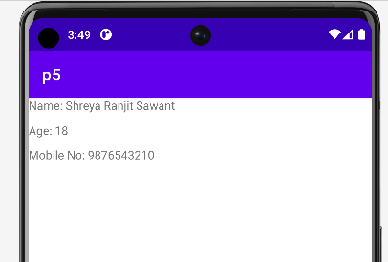

Q2.
<?xml version="1.0" encoding="utf-8"?>
<AbsoluteLayout xmlns:android="http://schemas.android.com/apk/res/android"
xmlns:app="http://schemas.android.com/apk/res-auto"
xmlns:tools="http://schemas.android.com/tools"
android:layout_width="match_parent"
android:layout_height="match_parent"
android:paddingLeft="16dp"
android:paddingTop="16dp"
android:paddingRight="16dp"
tools:context=".MainActivity">
<TextView
android:id="@+id/student_name"
android:layout_width="wrap_content"
android:layout_height="wrap_content"
android:layout_x="125dp"
android:layout_y="280dp"
android:text="Name:Shreya Ranjit Sawant"
android:textSize="20dp"
android:textStyle="bold"/>
<TextView
android:layout_width="wrap_content"
android:layout_height="wrap_content"
android:layout_x="125dp"
android:layout_y="304dp"
android:text="Age:18"
android:textSize="20dp"
android:textStyle="bold"/>
<TextView
android:layout_width="wrap_content"
android:layout_height="wrap_content"
android:layout_x="125dp"
android:layout_y="328dp"
android:text="Mobile No:9876543210"
android:textSize="20dp"
android:textStyle="bold"/>
</AbsoluteLayout>

package com.example.p5;
import androidx.appcompat.app.AppCompatActivity;
import android.os.Bundle;
public class MainActivity extends AppCompatActivity {
@Override
protected void onCreate(Bundle savedInstanceState) {
super.onCreate(savedInstanceState);
setContentView(R.layout.activity_main);
}
}
Output:
